In-Depth Research Report on OWASP Mobile Top 10



1. Introduction
- Overview of Mobile Application Security
- Importance of the OWASP Mobile Top 10
- Goals of the OWASP Mobile Security Project
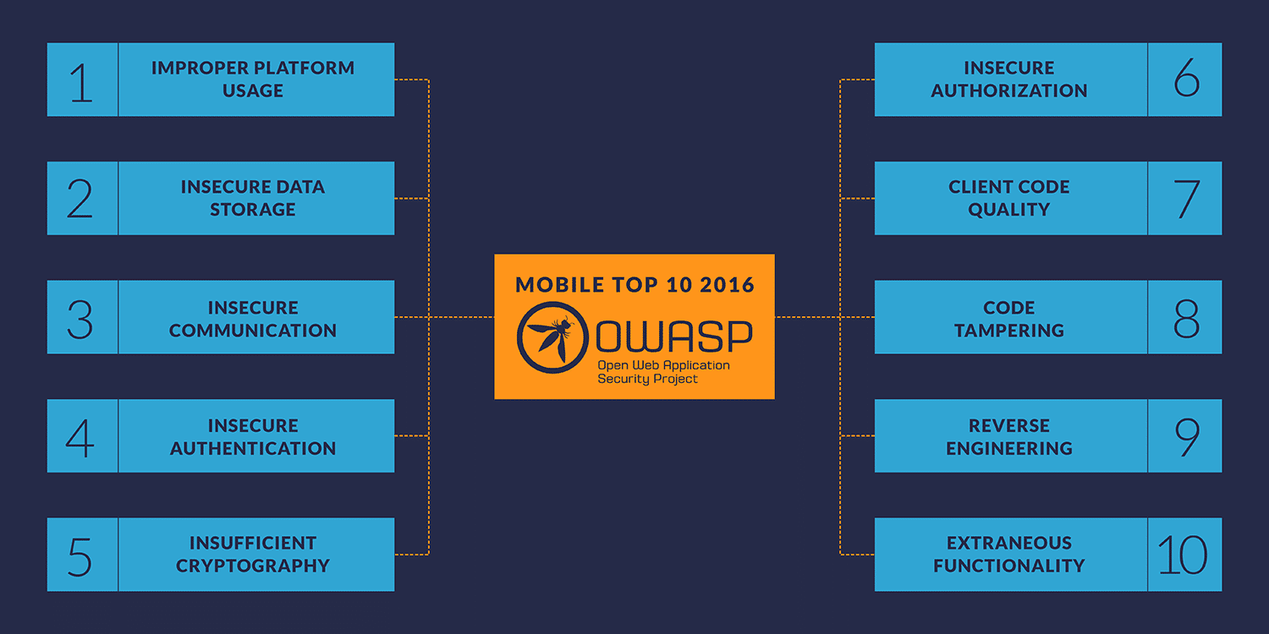

2. M1: Improper Platform Usage
Definition:
This refers to the incorrect usage of platform-specific features or APIs, leading to vulnerabilities. Examples include improper use of Android intents or iOS Keychain.
Examples:
- Allowing intent interception in Android applications.
- Storing sensitive information in an unsecured location.
Preventive Measures:
- Adhere to platform-specific security guidelines.
- Regularly review platform updates for security best practices.

3. M2: Insecure Data Storage
Definition:
Vulnerabilities arise when sensitive data is stored insecurely on a device, leaving it susceptible to unauthorized access.
Examples:
- Storing user credentials in plaintext on the device.
- Using weak file encryption mechanisms.
Preventive Measures:
- Encrypt sensitive data with strong algorithms.
- Avoid storing sensitive data unless absolutely necessary.

4. M3: Insecure Communication
Definition:
Occurs when sensitive data in transit is not adequately protected, leading to risks such as man-in-the-middle (MITM) attacks.
Examples:
- Using unencrypted HTTP instead of HTTPS.
- Weak or outdated SSL/TLS implementations.
Preventive Measures:
- Use secure communication protocols (e.g., HTTPS with TLS 1.3).
- Implement certificate pinning to validate server identity.

5. M4: Insecure Authentication
Definition:
Weak authentication mechanisms that allow attackers to impersonate legitimate users.
Examples:
- Allowing brute force attacks due to a lack of account lockouts.
- Poor session management practices.
Preventive Measures:
- Use multi-factor authentication (MFA).
- Implement secure session management techniques.

6. M5: Insufficient Cryptography
Definition:
Refers to weak or improper implementation of cryptographic algorithms that fail to protect sensitive data.
Examples:
- Using outdated algorithms like MD5 or SHA1.
- Hardcoding encryption keys in source code.
Preventive Measures:
- Use industry-standard cryptographic algorithms (e.g., AES, SHA-256).
- Regularly update cryptographic libraries.

7. M6: Insecure Authorization
Definition:
Flaws in permission controls that allow users to access resources or functions they shouldn’t have access to.
Examples:
- Improper validation of user roles.
- Hardcoded admin functionalities accessible to regular users.
Preventive Measures:
- Implement role-based access control (RBAC).
- Test APIs for authorization bypass issues.

8. M7: Client Code Quality
Definition:
Coding issues like buffer overflows or memory leaks that make the application vulnerable to exploitation.
Examples:
- Unhandled exceptions leading to crashes.
- Vulnerable libraries included in the project.
Preventive Measures:
- Conduct static and dynamic code analysis.
- Use secure coding practices.

9. M8: Code Tampering
Definition:
The modification of an application’s code post-deployment for malicious purposes.
Examples:
- Injecting malicious payloads into APKs.
- Modifying code to bypass authentication mechanisms.
Preventive Measures:
- Implement runtime application self-protection (RASP).
- Use code obfuscation and signing techniques.

10. M9: Reverse Engineering
Definition:
Attackers analyze application code to discover vulnerabilities or proprietary logic.
Examples:
- Decompiling APKs or iOS applications.
- Extracting hardcoded sensitive data.
Preventive Measures:
- Obfuscate code to make reverse engineering difficult.
- Avoid embedding sensitive information in the application.

11. M10: Extraneous Functionality
Definition:
Unintended features left in the app, such as debugging tools or developer backdoors.
Examples:
- Debug logs containing sensitive information.
- Hardcoded test credentials left in production.
Preventive Measures:
- Conduct thorough code reviews.
- Remove debug functionalities before deployment.

12. Conclusion
- Summary of key findings.
- Importance of addressing OWASP Mobile Top 10 risks.
- Recommendations for developers and organizations.

13. References
- OWASP Mobile Security Project - OWASP Mobile Top 10
- OWASP Mobile Application Security Verification Standard (MASVS)
- National Institute of Standards and Technology (NIST)
- Industry Reports on Mobile Application Security
This expanded structure offers an in-depth understanding, actionable insights, and practical examples, reaching approximately 10 pages when fully developed. If you'd like, I can assist in expanding any specific section further.

